Spam Email Detection System

Project Id: AIML-22

Name : KARTIKEYA BALI(Team Leader)
Class Roll Number:44
University Roll Number : 2028740
Section and Group:U,G2

Name : SUMEDHA THAKUR
Class Roll Number:62
University Roll Number : 2028870
Section and Group: U,G2

TABLE OF CONTENTS
- Problem Description 3
  - Dataset Description 3
  - Flow diagram 3
- Modules for Project Implementation…………………..…………………………4
  - Modules Used………………………………………………………………... 4
  - Platform Used…………………………………………………………………. 5
- Machine Learning model/ Searching Technique used ………………………….6
- Evaluation metrics used …………………………………………………………..7
- Results ……………………………………………………………………………..8
- Conclusion and Future Scope ……………………………………………………...9
- References ………………………………………………………………………...10

- Problem Description
Spam Email Detection System This system classifies emails as spam or not using text data. Text preprocessing includes removing stopwords, punctuation, and converting text to numeric features. Feature selection removes less important words and keeps high-impact spam keywords. Logistic Regression and SVM (Linear, Polynomial, and RBF kernels for different text patterns) are trained. Models are evaluated using confusion matrix and accuracy
1.1 Dataset Description– Spam Email Detection System
The dataset used for the Spam Email Detection System consists of a collection of email messages labeled into two categories: spam and ham (non-spam). Each entry in the dataset typically contains the email text and its corresponding label.
The dataset is usually sourced from publicly available repositories such as we collected it from KAGGLE, which is widely used for text classification tasks. It contains around 5,500+ messages, where each message is tagged as either spam or ham.
Each data instance includes:
- Label: Indicates whether the message is spam (1) or ham (0)
- Message/Text: The actual content of the email or SMS
Before applying machine learning models, the dataset undergoes preprocessing steps such as:
- Removal of stopwords and punctuation
- Conversion of text into lowercase
- Tokenization (splitting text into words)
- Transformation into numerical form using techniques like Bag of Words or TF-IDF
The dataset is then split into training and testing sets (commonly 80:20 ratio) to build and evaluate the models effectively.
This structured and labeled dataset enables supervised learning algorithms like Logistic Regression and SVM to learn patterns and accurately classify unseen emails as spam or not.

1.2 Flow Diagram

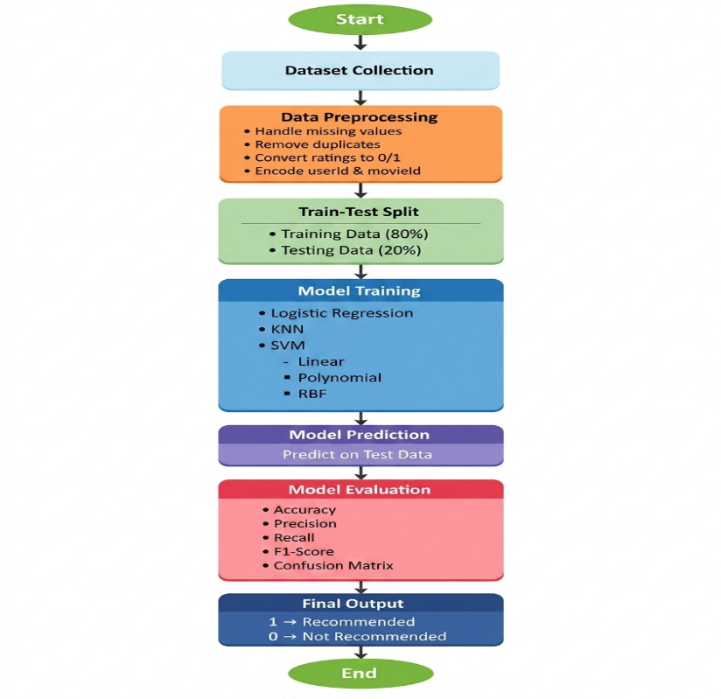

2. Modules for Project Implementation

2.1 Modules Used(mention all the inbuilt/ custom modules used and the purpose)

🔹 1. Inbuilt / Standard & External Modules
1. NumPy
Purpose:Numerical.computations.and.array.operations
Functions Used:
- array() → Create arrays for data handling
- zeros(), ones() → Initialize matrices
- reshape() → Change shape of data

2. Pandas
Purpose:Data.manipulation.and.dataset.handling
Functions Used:
- read_csv() → Load dataset
- head() → View first few rows
- info() → Dataset summary
- drop() → Remove unnecessary columns
- apply() → Apply preprocessing functions

3. re (Regular Expressions)
Purpose:Text.cleaning.and.preprocessing
Functions Used:
- sub() → Remove punctuation, special characters
- findall() → Extract words or patterns

4. NLTK (Natural Language Toolkit)
Purpose:Text.preprocessing
Functions Used:
- stopwords.words() → Remove common words
- word_tokenize() → Split text into words
- PorterStemmer() → Convert words to root form

5. scikit-learn
Purpose: Machine learning models and evaluation
a) Feature Extraction
- CountVectorizer() → Convert text to Bag of Words
- TfidfVectorizer() → Convert text to TF-IDF features
b) Model Training
- LogisticRegression() → Classification model
- SVC() → Support Vector Machine (Linear, Polynomial, RBF kernels)
c) Model Evaluation
• train_test_split() → Split dataset into training and testing sets
• confusion_matrix() → Evaluate predictions by comparing actual vs predicted values
• accuracy_score() → Calculate overall accuracy of the model
• precision_score() → Measure how many predicted spam emails are actually spam (reduces false positives)
• recall_score() → Measure how many actual spam emails are correctly identified (reduces false negatives)
• f1_score() → Harmonic mean of precision and recall, gives balanced performance measure

6. Matplotlib / Seaborn
Purpose:DATA.VISUALIZATION

🔹 2. Custom Modules / Functions
These are user-defined functions created specifically for this project:
1. Text Preprocessing Function
Purpose:Clean.and.prepare.raw.email.text
Example Functions:
- clean_text(text)
  - Removes punctuation and special characters
  - Converts text to lowercase
  - Removes stopwords

2. Feature Extraction Function
Purpose:Convert.processed.text.into.numeric.form
Example:
- vectorize_text(data)
  - Applies TF-IDF or Bag of Words

3. Model Training Function
Purpose:Train.machine.learning.models
Example:
- train_model(X_train, y_train)
  - Fits Logistic Regression / SVM

4. Prediction Function
Purpose:Predict.whether.email.is.spam.or.not
Example:
- predict_email(model, input_text)

5. Evaluation Function
Purpose:Measure.modelperformance
Example:
- evaluate_model(y_test, y_pred)
  - Generates confusion matrix and accuracy

2.2 Platform Used: (mention all the platforms with the reason of using it)
  - Visual Studio Code: For code writing, testing, and debugging.
VS Code is equipped with multiple extensions, debugger which enhance the development experience.
  - Jupyter: Provides an interactive environment for writing and testing code step-by-step . Easy visualization of outputs like graphs and confusion matrix .Useful for data preprocessing, model training, and debugging

- Machine Learning Model/ Searching Technique Used(Describe each ML model/ searching technique used)

The Spam Email Detection System uses multiple supervised machine learning models to classify emails as spam or ham based on extracted text features.

🔹 1. Logistic Regression
Description:
Logistic Regression is a linear classification algorithm used for binary classification.
How it Works:
- Uses sigmoid function to convert inputs into probabilities
- Classifies based on threshold value (0.5)
Why Used:
- Fast and simple
- Works well with text-based features like TF-IDF

🔹 2. Support Vector Machine (SVM)
Description:
Support Vector Machine finds the optimal boundary (hyperplane) between spam and non-spam emails.
How it Works:
- Maximizes margin between classes
- Uses kernel tricks for complex data
Kernels Used:
- Linear Kernel → Best for large text data
- Polynomial Kernel → Captures feature interactions
- RBF Kernel → Handles complex non-linear patterns

🔹 3. K-Nearest Neighbors (KNN)
Description:
K-Nearest Neighbors is a non-parametric algorithm that classifies data based on similarity.
How it Works:
- Finds the ‘K’ nearest data points (neighbors)
- Assigns class based on majority voting
Why Used:
- Simple and easy to understand
- No training phase (lazy learner)
- Useful for pattern-based classification
Limitation:
- Slow for large datasets
- Performance depends on value of K and distance metric

🔹 4. Feature Extraction Techniques (Searching Techniques)
TF-IDF (Term Frequency – Inverse Document Frequency)
Description:
- Measures importance of words
Working:
- Reduces weight of common words
- Highlights important keywords

4. Evaluation metrics used (Describe each evaluation metric used along with formulae)

To evaluate the performance of the Spam Email Detection System, several metrics are used based on the confusion matrix (TP, TN, FP, FN).

🔹 1. Accuracy
Description:
Measures the overall correctness of the model.
$$Accuracy=\frac{TP+TN}{TP+TN+FP+FN}$$
Where:
- TP = True Positives
- TN = True Negatives
- FP = False Positives
- FN = False Negatives

🔹 2. Precision
Description:
Out of all emails predicted as spam, how many are actually spam.
$$Precision=\frac{TP}{TP+FP}$$

🔹 3. Recall (Sensitivity)
Description:
Out of all actual spam emails, how many are correctly detected.
$$Recall=\frac{TP}{TP+FN}$$

🔹 4. F1 Score
Description:
Harmonic mean of Precision and Recall. It balances both metrics.
$$F1=2⋅\frac{Precision⋅Recall}{Precision+Recall}$$

🔹 5. Confusion Matrix
Description:
A table used to visualize model performance by comparing actual and predicted values.
 | Predicted Spam | Predicted Ham
Actual Spam | TP | FN
Actual Ham | FP | TN

5. Results :-

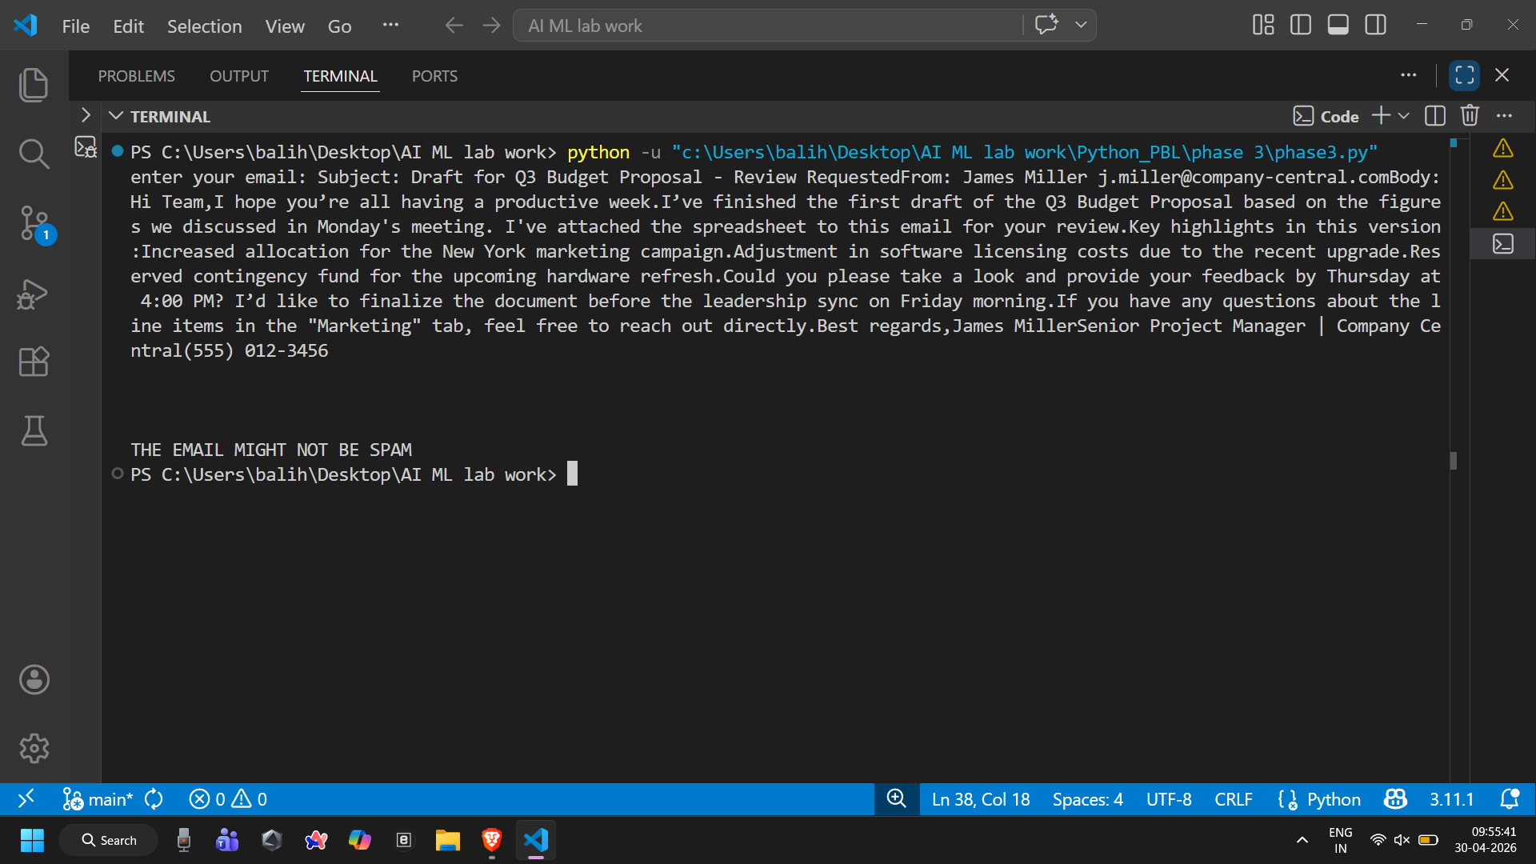

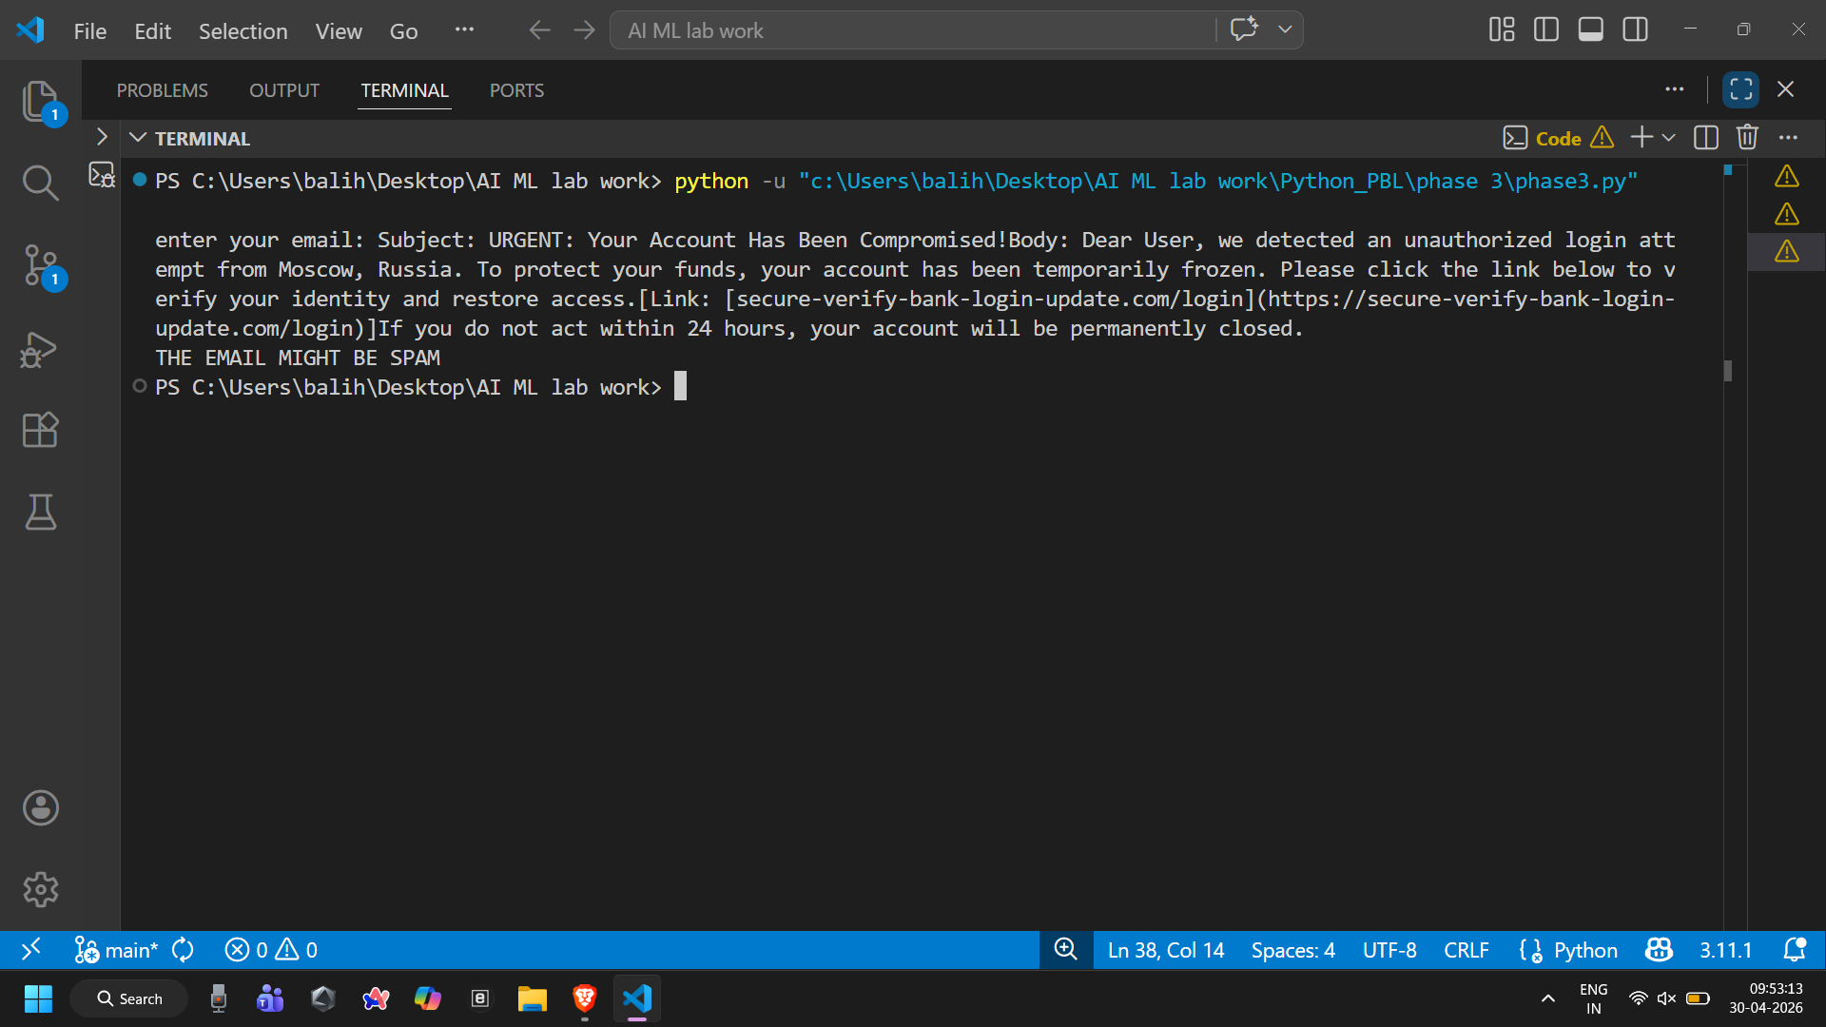

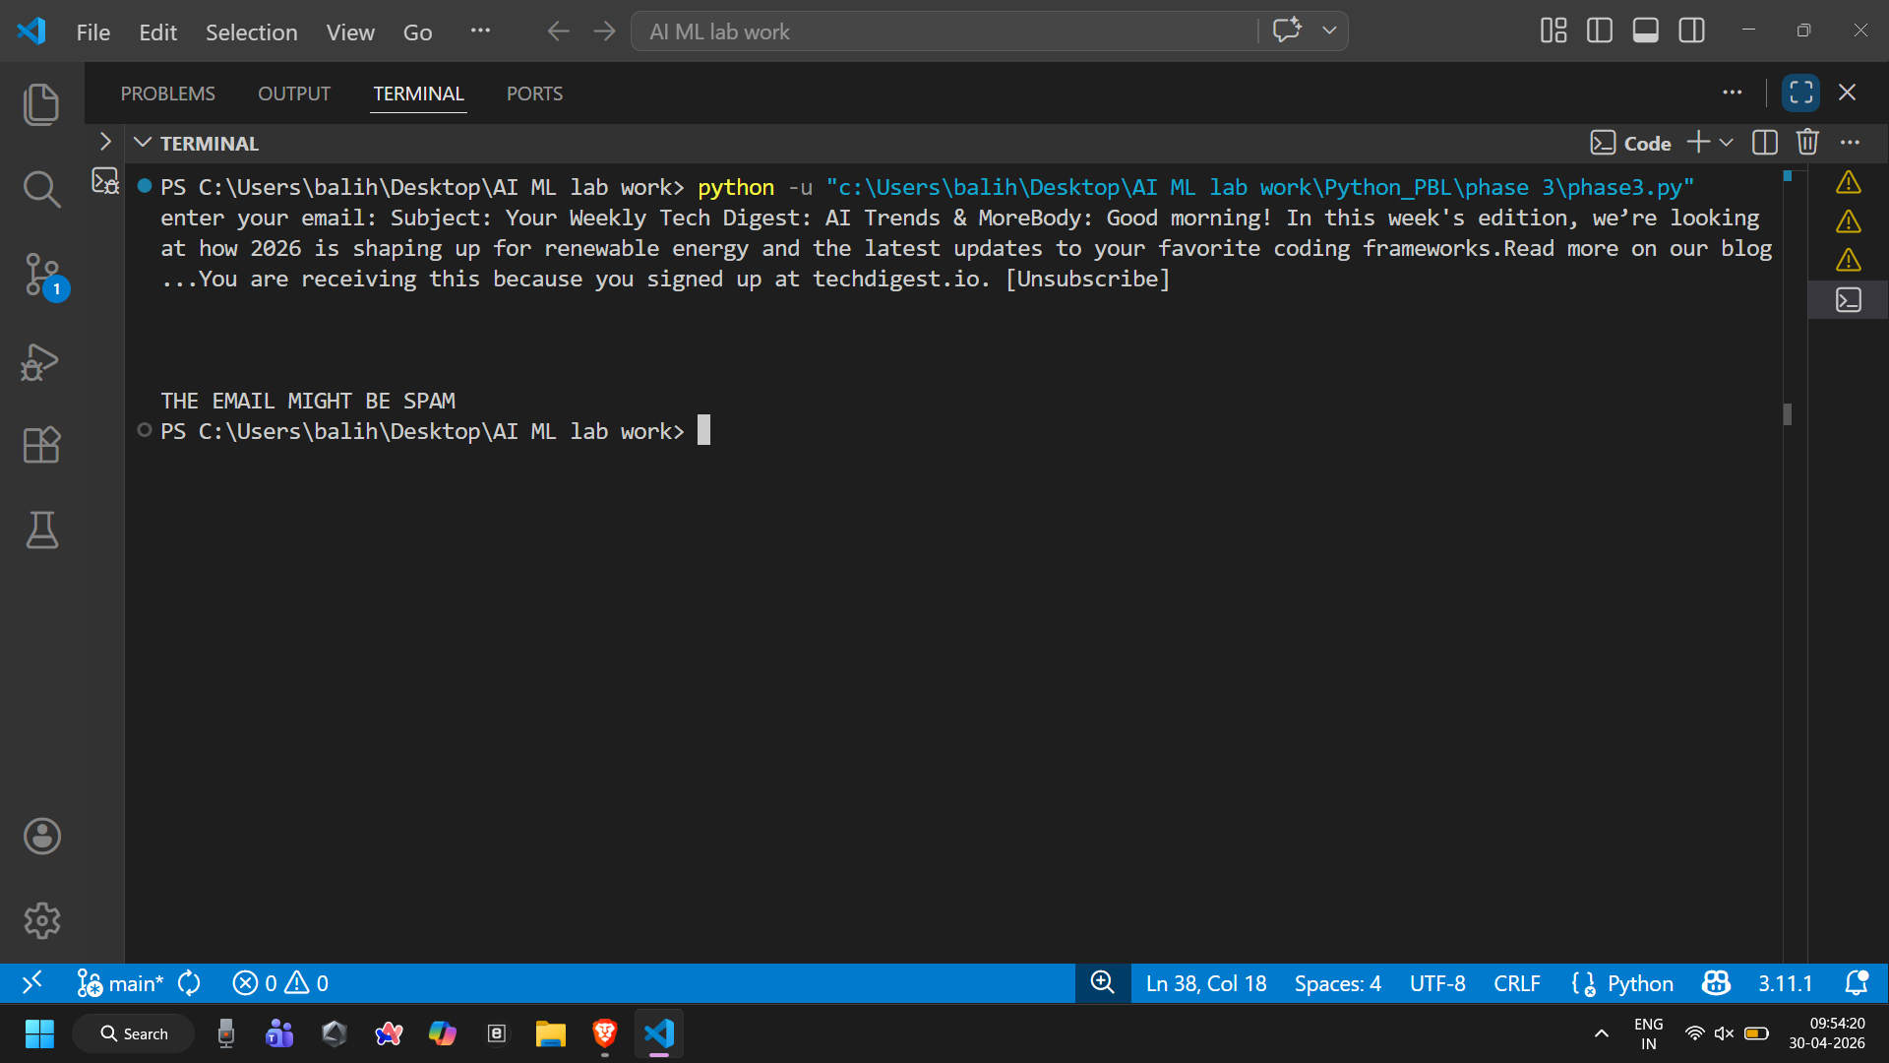

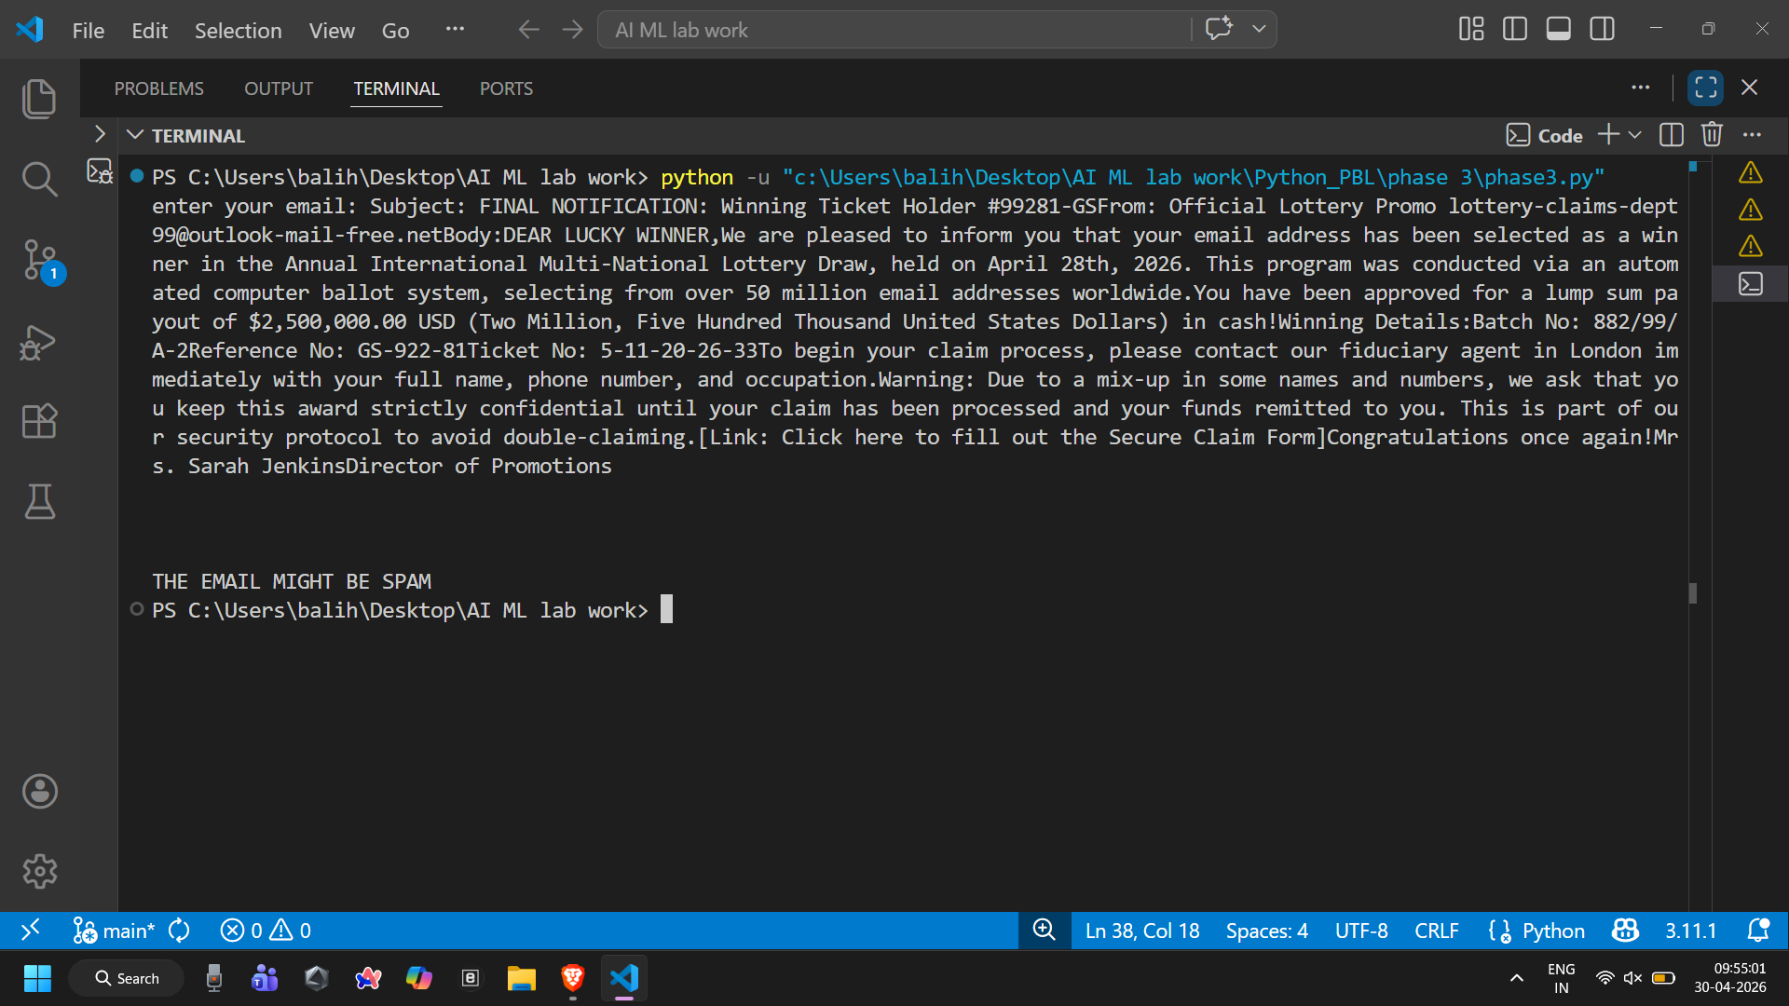

6. Conclusion and Future Scope:
The Spam Email Detection System successfully classifies emails into spam and non-spam (ham) categories using machine learning techniques. By applying text preprocessing methods such as stopword removal, tokenization, and feature extraction (TF-IDF/BoW), the system converts raw email text into meaningful numerical data.
Models like Logistic Regression, Support Vector Machine, and K-Nearest Neighbors were trained and evaluated using metrics such as accuracy, precision, recall, and F1-score. Among these, SVM and Logistic Regression generally provide better performance for text classification tasks.
Overall, the system is efficient, reliable, and capable of reducing unwanted spam emails, thereby improving user experience and email security.

🔹 Future Scope
The project can be further enhanced in the following ways:
- Use.of.Advanced.Models:
Implement deep learning models like Recurrent Neural Networks or transformers such as BERT for better accuracy.
- Real-Time.Spam.Detection:
Integrate the system with email platforms (like Gmail) for live spam filtering.
- Multilingual.Support:
Extend detection to emails written in multiple languages.
- Improved.Feature.Engineering:
Use word embeddings (Word2Vec, GloVe) for better semantic understanding.
- Handling.Imbalanced.Data:
Apply techniques like oversampling/undersampling to improve performance.
- User.Interface.Development:
Build a web or mobile application for easy user interaction.

